ANALYSING HOUSING PRICES IN METROPOLITAN AREAS OF INDIA

INTRODUCTION

Overview:

The rising inflation in urban housing has risen to 4.47%year-on-year in December 2022v/s 3.61% in the same period a year before.

Purpose:

The rise and fall of house prices can have big implications for the economy.Price increase generally create more jobs, stimulate confidence,and prompt higher consumer spending.

PROBLEM DEFINITION AND DESIGN THINKING

Brain storming:



The above diagram shows the brain storming of housing prices in metropolitan of india

EMPATHY Map:

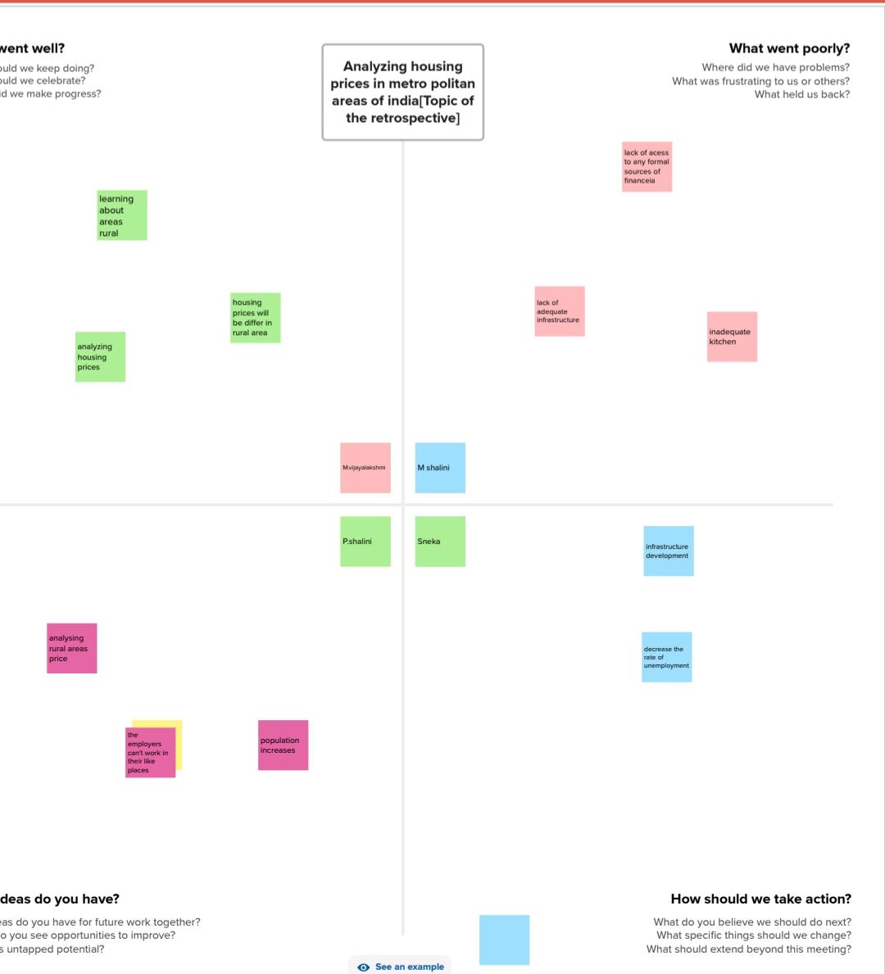

Dash board:

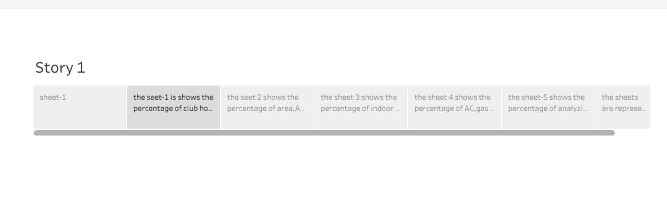

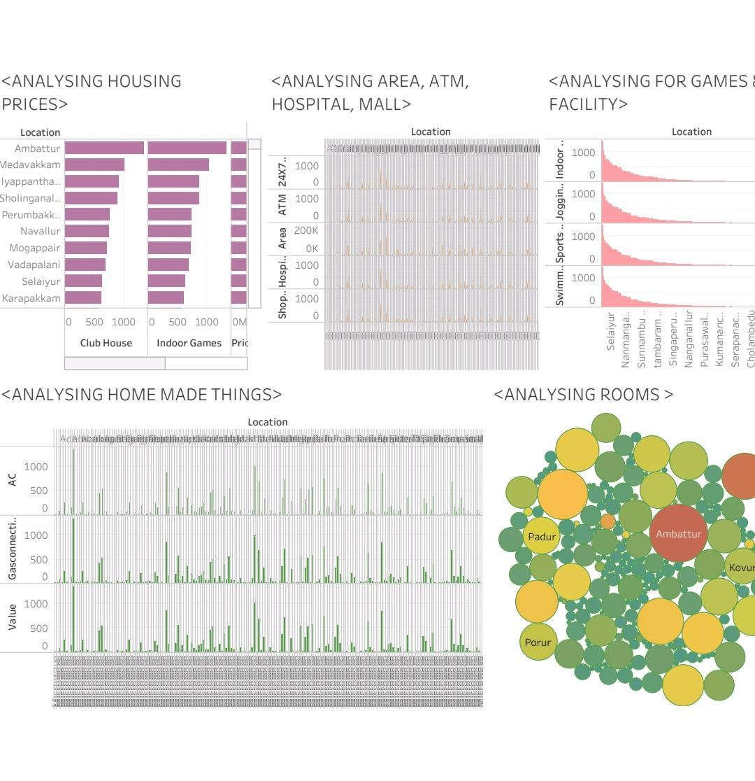

Story

Advantage:

* This rise in housing wealth has facilitated growth in household consumption,allowed for generally lower levels of discretionary household savings and has been afactor supporting economic growth

Disadvantages:

* The prices of houses are high.
* It is not possible to poor people because of unemployment.

Conclusion:

The housing prices are very important now a days.

Due to high housing prices,people’s are like to live in urban side